1. INTRODUCTION
1.1 Introduction:
Women are highly trained at mobilizing diverse groups for frequent causes. They often work across racial, sacred, opinionated, and intellectual divides to encourage tranquillity. We are aware of importance of women's security, but we must recognize that they need to be secured. A lady isn't much powerful as compared to men physically, during a crisis situation and needs a hand to alleviate them. the simplest because of minimize chances in becoming a victim of violent crime (robbery, sexual assault , rape, domestic violence) is to identify and switch resources to help you out of unsafe situations. Whether you're in instant trouble or got separated from friends during night and do not skills to urge home, having these apps on your phone can diminish your risk and convey assistance once you need it. Within the light of recent outrage in Delhi which shook the state and woke us to the security issues for our daughters, public are gearing upbeat in several ways to fight back. A swarm of latest apps are developed to provide security systems to women on their phones.
Here, we introduce another android application that provides the safety for women. It helps them to feel safe and secured when they are outside of their residence. The key features of our app make it different from other apps:
This app uses Google as its backend. The user must have Google app. Initially the user has to register and give all access permissions. And she can add any three contacts whenever she needs help, she can ask by her voice itself. She doesn’t need to use her hand anymore for help.

1.2 Purpose:
This system can be used as an application for the people who are in danger. It is helpful for every individual who need help from others quickly. Mainly, the women who need help from some situations like harassments, eve teasing etc.

2. SYSTEM ANALYSIS
2.1 Introduction
System analysis is a problem-solving method that involves looking at the winder system, breaking apart the parts, and figuring out how it works in order to achieve a particular goal. System analysis to investigate problems and identify solutions .Analysis specifies what the system should do.
2.2 Analysis Model
The model that is basically being followed is the WATERFALL MODEL, which states that the phases are organized in a linear order. First of all the feasibility study is done. Once that part is over the requirement analysis and project planning begins. If system exists one and modification and addition of new module is needed, analysis of present system can be used as basic model. The design starts after the requirement analysis is complete and the coding begins after the design is complete. Once the programming is completed, the testing is done. In this model the sequence of activities performed in a software development project are:
- Requirement Analysis
- Project Planning
- System design
- Coding
- Unit testing
- System integration & testing
Here the linear ordering of these activities is critical. End of the phase and the output of the one phase is the input of other phase. Some of the qualities of spiral model are also incorporated like after the people concerned with the project review completion of each of the phase the work done. WATERFALL MODEL was being chosen because all requirements were known beforehand and the objective of our software development is the online house rental system.
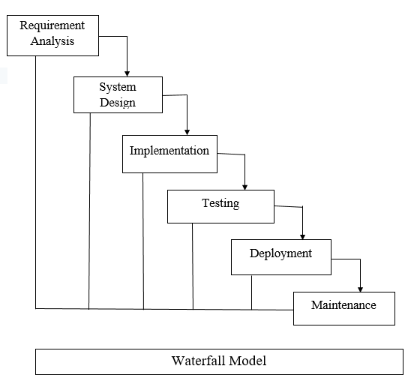
Fig1: Waterfall Model

2.3 Modules
This project contains the following five modules.
Modules
User Module
Register My Contacts
Display Contacts
Server Module

User Module
Go_Safe android application is installed by the user in her mobile and initiated by user Mobile Number.
- Initially the security app called go safe needs to be installed in the mobile.
- Then user should enrol her mobile number.
- And then click on submit button.
- Then it toasts submitted successfully.
- If the mobile number is already existed in the server module, it toasts the user already existed.

Register My Contacts
The user should enrol the contacts to whom the user wants to send SMS and call when she senses danger. The contact which is given at first will get both call and SMS & the remaining numbers will only get SMS.
Display Contacts
The numbers which are stored by the user will display here.
Server Module
This module helps us to register and after registration it helps us to search different information regarding the college. Here the student can update their details, view alumni details and post their queries on jobs and get updated.

2.4 Proposed System
In order to give a better facility to women, this is an innovative mobile application that enables a person to feel security whenever they are in critical situations. By using location based GPS service we connect real-time and to the right people. This application is useful because the person can ask for help by his voice to send the message. This application will recognize the voice on the lock screen itself.
By this application the user can send the location in the form of a map Hyperlink through SMS and the link can be viewed on the Google maps.

Advantages of proposed system:
- This application has a voice recognition on the lock-screen itself.
- In this application, the user just needs to register once then he can able to use the service of it.
- It includes additional security for users.
- For example if a user is in critical situation and unable to catch the mobile, he/she can ask for help by his voice. Then the application activates and recognize voice of that person from 100mts far and then send the SMS along with location link to the numbers which are stored database.
- By this application, we can save at least 90% of the population who are in dangerous situations.
This is mainly helpful to women who can’t able to protect themselves in some conditions like harassment and gang-rapes.
2.5 Existing System
There is a lot of security applications available having similar functionalities of this system. In existing system, when a person is in danger he/she can get survived by the android application where the person has to click on a particular button existed in the application. By this, the SMS along with location link will be sent to the contacts stored in database. There is another application where the user has to shake the mobile when he/she need help. This application is also having a facility to send the SMS along with GPS location link.

1. NIRBHAYA:- This is an android app where the user needs to click on specific button when she needs help. The button allows sending the SMS along with her location to the numbers stored in database.
2. ABHAYA:- This is an android app where the user need to click on a button, and works same as NIRBHAYA, but it continuously send SMS for every 5 minutes until the user press stop button.

3. VANITHA ALERT:- In this app the user need to click on '' HELP” button on her mobile's home screen whenever she is in emergency situation. It can deliver a text message to the registered mobile number, E-mail id, and facebook id seeking help and indicating the user's location.

Limitations in Existing System:
- Whenever a person is in danger, he/she has to click on particular button to send SMS.
- But the person may not be able to unlock the device, open the app and click the button in some situations where it is a time consuming process.
- At that time, they need a facility to send the SMS without opening the mobile.
- These applications 80% of people can be survived but remaining 20% are facing trouble due to their inability to catch the mobile.

3. FEASIBILITY STUDY
The next step in analysis is to verify the feasibility of the proposed system. Feasibility study is a high-level capsule version of the entire process intended to answer a number of questions like: What is the problem? Are there any feasible solutions to the given problem? Is the problem even worth solving? Feasibility study is conducted once the problem is clearly understood. Feasibility study is necessary to determine that the proposed system is feasible by considering the technical, Operational, and Economical factors. By having a detailed feasibility study the management will have a clear-cut view of the proposed system.
Preliminary investigation examines project feasibility, the likelihood the systems will be use full to the organization. The main objective of the feasibility is to test the Technical, Operational, Economical feasibility if they are unlimited resources and infinite time. The following feasibilities are considered for the project in order to ensure that the project is variable and it does not have any major obstructions. Feasibility study encompasses the following thing:
1. Technical Feasibility
2. Operational Feasibility
3. Economical Feasibility
3.1 Technical Feasibility
Technical feasibility is one of the first studies that must be conducted after the project has been identified. In large engineering projects consulting agencies that have large staffs of engineers and technicians conduct technical studies dealing with the projects. For example, In individual agricultural projects financed by local agricultural credit corporations, the technical staff composed of specialized agricultural engineers, irrigation and construction engineers, and other technicians are responsible for conducting such feasibility studies.

The first step in the feasibility stage, Technical Feasibility, involves development of a working model of the product or service. It is not necessary that the initial materials and components of the working model represent those that actually will be used in the finished product or service. The purpose of the working model is to demonstrate, to your own satisfaction, that the product or service is functional and producible. It also provides a visual means to share your concept with others. The concept of a mechanical working model is easier to grasp and understand than software, ecommerce or service-related products. E-commerce models require verification of the ability to integrate the computers, servers, software and programming needed to support the operational concept. Services, packaged as a set of value-added activities, should deliver observable benefits.

- A brief description of the business to assess more possible factors which could affect the study.
- All necessary technology exists to develop the system.
- This system is too flexible and it can be expanded further.
- This system can give guarantees of accuracy, ease of use, reliability and the data security.
- This system can give instant response to inquire.
- The human and economic factor.
- The possible solutions to the problem.

As we are developing this Application on Android Studio Platform 4.1.1 version which is an open source and free of cost. Once we started developing this application in Android Studio platform edition then there is no need of purchasing any special software or application software for support.

3.2 Operational Feasibility:

Operational feasibility assesses the extent to which the required software performs a series of steps to solve business problems and user requirements. This feasibility is dependent on human resources (software development team) and involves visualizing whether the software will operate after it is developed and be operative once it is installed.
In this step, we verify different operational factors of the proposed system like man-power, time etc, whichever solution uses less operational resources, is the best operationally feasible solution. The solution should also be operationally possible to implement. Operational Feasibility determines if the proposed system user objectives could be fitted into the current system operation.

Operational feasibility also performs the following tasks:
- Determines whether the problem anticipated in user requirements are of high priority.
- Determines whether the solution suggested by the software development team is acceptable.
- Analyse whether users will adapt to a new software.
- Determines whether the organization is satisfied by the alternative solutions proposed by the software development team.
- The methods of proposing and presentation are completely accepted by the clients since they can meet all user requirements.
- The clients have been involved in the planning and development of the system.
- The proposed system will not cause any problem under any circumstances.

Users who are using this application don’t require much knowledge of how to use. Everything will be understood by user once she sees the application. So our project is operationally feasible.

3.3 Economical Feasibility:

Economic feasibility determines whether the required software is capable of generating financial gains for an organization. It involves the cost incurred on the software development team, estimated cost of hardware and software, cost of performing feasibility study and so on.
Economically, this project is completely feasible because it requires no extra financial investment and with respect to time, it’s completely possible to complete this project in 6 months. In this step, we verify which proposal is more economical. We compare the financial benefits of the new system with new investment. The new system is economically feasible only when the financial benefits are more than the investments and expenditure. Economic feasibility determines whether the project goal can be within the resource limit allocated to it or not. It must determine whether it is worthwhile to process with the entire project or whether the benefits obtained from the new system are not worth the costs. Financial benefits must be equal or exceed the costs.

Software is said to be economically feasible if it focuses on the issues listed below.
- Cost incurred on software development to produce long-term gains for an organization.
- Cost required conducting full software investigation (such as requirements elicitation and requirements analysis).
- Cost of hardware, software, development team, and training.
- The cost to conduct a full system investigation.
- The cost of hardware and software for the class of application being considered.
- The development tools.
- The cost of maintenance etc.
Economically, this project is completely feasible because it requires no extra financial investment and with respect to time, it's completely possible to complete this project in 6 months.

4. SOFTWARE REQUIREMENT SPECIFICATION
A software requirements specification (SRS) is a description of a software system to be developed. The software requirements specification lays out functional and non-functional requirements, and it may include a set of use cases that describe user interactions that the software must provide. The software requirements specification document lists sufficient and necessary requirements for the project development.
4.1 Functional Requirements
These are statements of services the system should provide, how the system should react to particular inputs, and how the system should behave in particular situations, it specifies the application functionality that the developers must build into the product to enable users to accomplish their tasks.

- The App need some permissions to be accessed.
- The user can use the app services by accessing the permissions.
- The users can give contacts as their wish.
- User can replace the contacts.
- The app can access voice according to the microphone access.
- When the user gives permissions and store contacts, the app always run on the background.
- The application sends the SMS to all stored contacts and call to only first stored contact.
- User can store 5 contacts.
- If user wants to store other contacts except first 5, the first stored contacts will be replaced by newly stored contacts.

Non-Functional Requirements
Access Security
The extent to which the system is safeguarded against deliberate and intrusive faults from internal and external sources.
Accessibility
The extent to which the software system can be used by people with the widest range of capabilities to achieve a specified goal in a specified context of use.
Availability
The degree to which users can depend on the system to be up (able to function) during “normal operating times”.
Confidentiality
The degree to which the software system protects sensitive data and allows only authorized access to the data.
Efficiency
The extent to which the software system handles capacity, throughput, and response time.
Integrity
The degree to which the data maintained by the software system are accurate, authentic, and without corruption.
Reliability
The extent to which the software system consistently performs the specified functions without failure.
Safety
The degree to which a software system prevents harm to people or damage to the environment in the intended context of use.
Survivability
The extent to which the software system continues to function and recovers in the presence of a system failure.
Usability
The ease with which the user is able to learn, operate, prepare inputs, and interpret outputs through interaction with a system.
Flexibility
The ease with which the software can be modified to adapt to different environments, configurations, and user expectations.
Maintainability
The ease with which faults in a software system can be found and fixed.
Modifiability
The degree to which changes to a software system can be developed and deployed efficiently and cost effectively.

4.2 Performance
Performance is measured in terms of output provided by the application. Requirements specifications play an important part in the analysis of the system. Only when the requirement specifications are properly given, it is possible to design a system, which will fit into required environment. It rests largely in the part the users of the existing system to given the requirement specification because they are the people who finally use the system. This is because requirements have to be known during to be initiated stages so that the system can be designed according to those requirements. It is very difficult to change the system once it has been designed and on the other hand designing a system, which does not cater to the requirements of the users, is of no use.
The requirement specification for any system can be broadly stated has given below:
- The system should be able to interface with the existing system.
- The system should be accurate.
- The system should be better than the existing system
- The existing system is completely depends on the users to perform all the duties.

4.3 Hardware Requirements
The section of hardware configuration is an important task related to the software development that may affect adversely on the speed and efficiency of the entire system. The process should be powerful to handle the entire operations.
- At least 250GB free disk space to check out the code and an extra 150GB to build it. For multiple builds, additional space is needed.
- A 64-bit environment is required for Android 2.3.X and higher versions, including the master branch.
- If the app is running in a virtual machine, at least 16GB of RAM is used.

4.4 Software Requirements
A major element in building a system is the section of compatible software since the software in the market is experiencing in geometric progression. Selected software should be acceptable by the user and as well as it should be feasible for the system. This document gives a detailed description of the software requirement specification. The study of requirement specification is focused specially on the functioning of the system. It allows the developer or analyst to understand the system, function to be carried out the performance level to be obtained and corresponding interfaces to be established.

- Operating system
- SDK manager along with Eclipse Software
- Java Development Kit
- Key Packages

5. SYSTEM DESIGN

5.1 Introduction

System design is the process of defining the elements of a system such as the architecture, modules and components, the different interfaces of those components and the data that goes through that system. It is meant to satisfy specific needs and requirements of a business or organization through the engineering of a coherent and well-running system.
System design implies a systematic approach to the design of a system. It may take a bottom-up or top-down approach, but either way the process is systematic where in it takes into account all related variables of the system that needs to be created- from the architecture, to the required hardware and software, right down to the data and how it travels and transforms throughout its travel the system. System design then overlaps with systems analysis, systems engineering and system architecture.

5.2 System Workflow

Class diagram
Class diagram consists of classes, interfaces, associations, and collaboration. Class diagrams basically represent the object-oriented view of a system, which is static in nature.
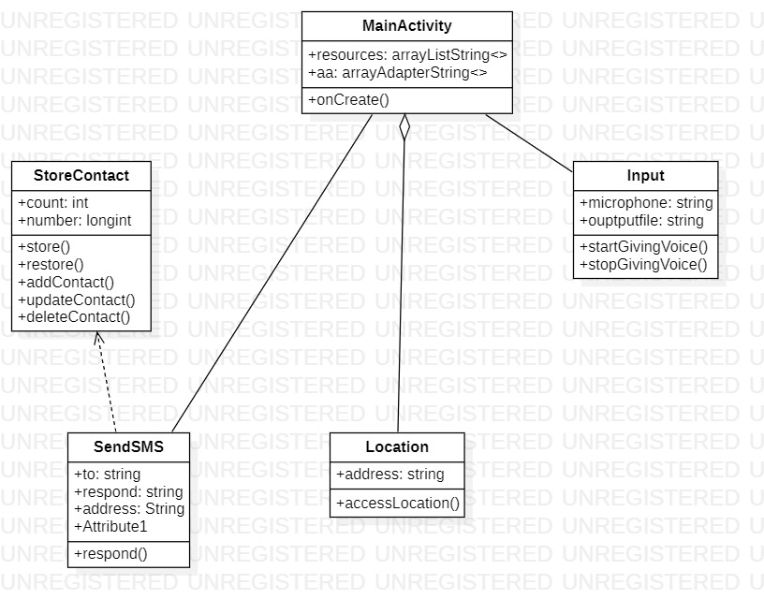
Fig 2: Class Diagram

Sequence Diagram
A sequence diagram simply depicts interaction between objects in a sequential order i.e. the order in which these interactions take place. We can also use the terms event diagrams or event scenarios to refer to a sequence diagram. Sequence diagrams describe how and in what order the objects in a system function.

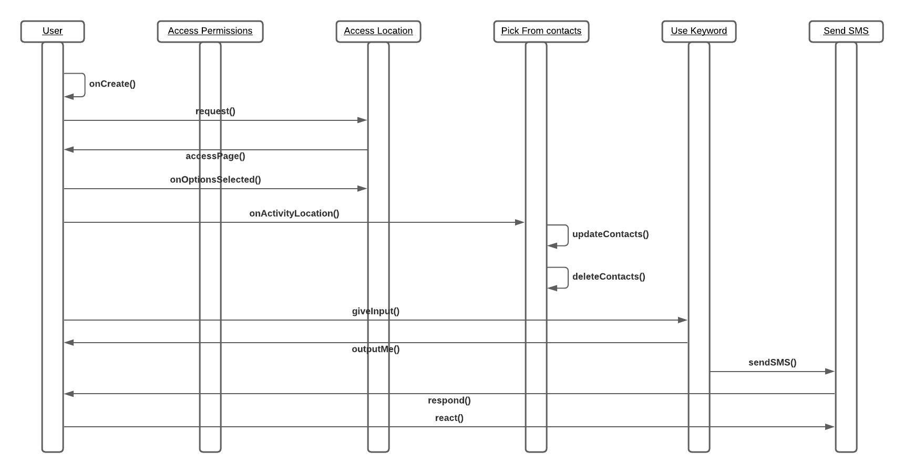
Fig 3: Sequence Diagram

Use case Diagram
A use case diagram at its simplest is a representation of a user's interaction with the system that shows the relationship between the user and the different use cases in which the user is involved.

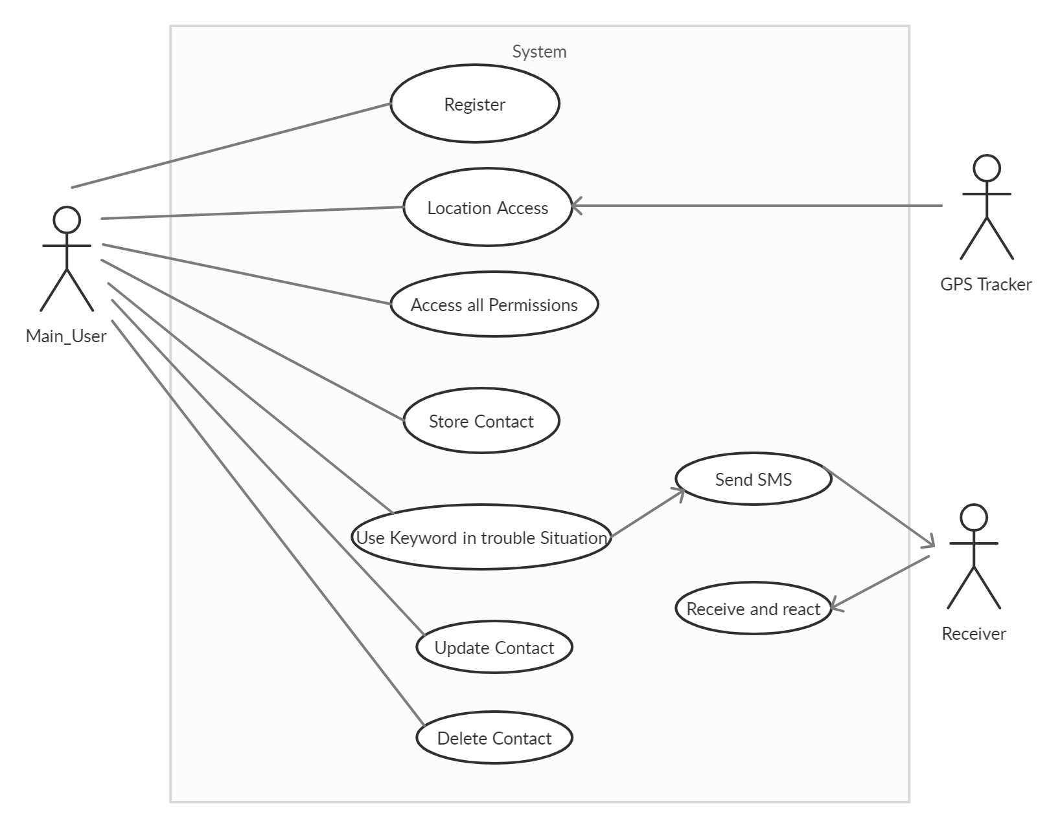
Fig 4: Use case Diagram

State chart diagram
A state chart diagram is a type of diagram used to describe the behavior of systems. State diagrams require that the system described is composed of a finite number of states; sometimes, this is indeed the case, while at other times this is a reasonable abstraction.
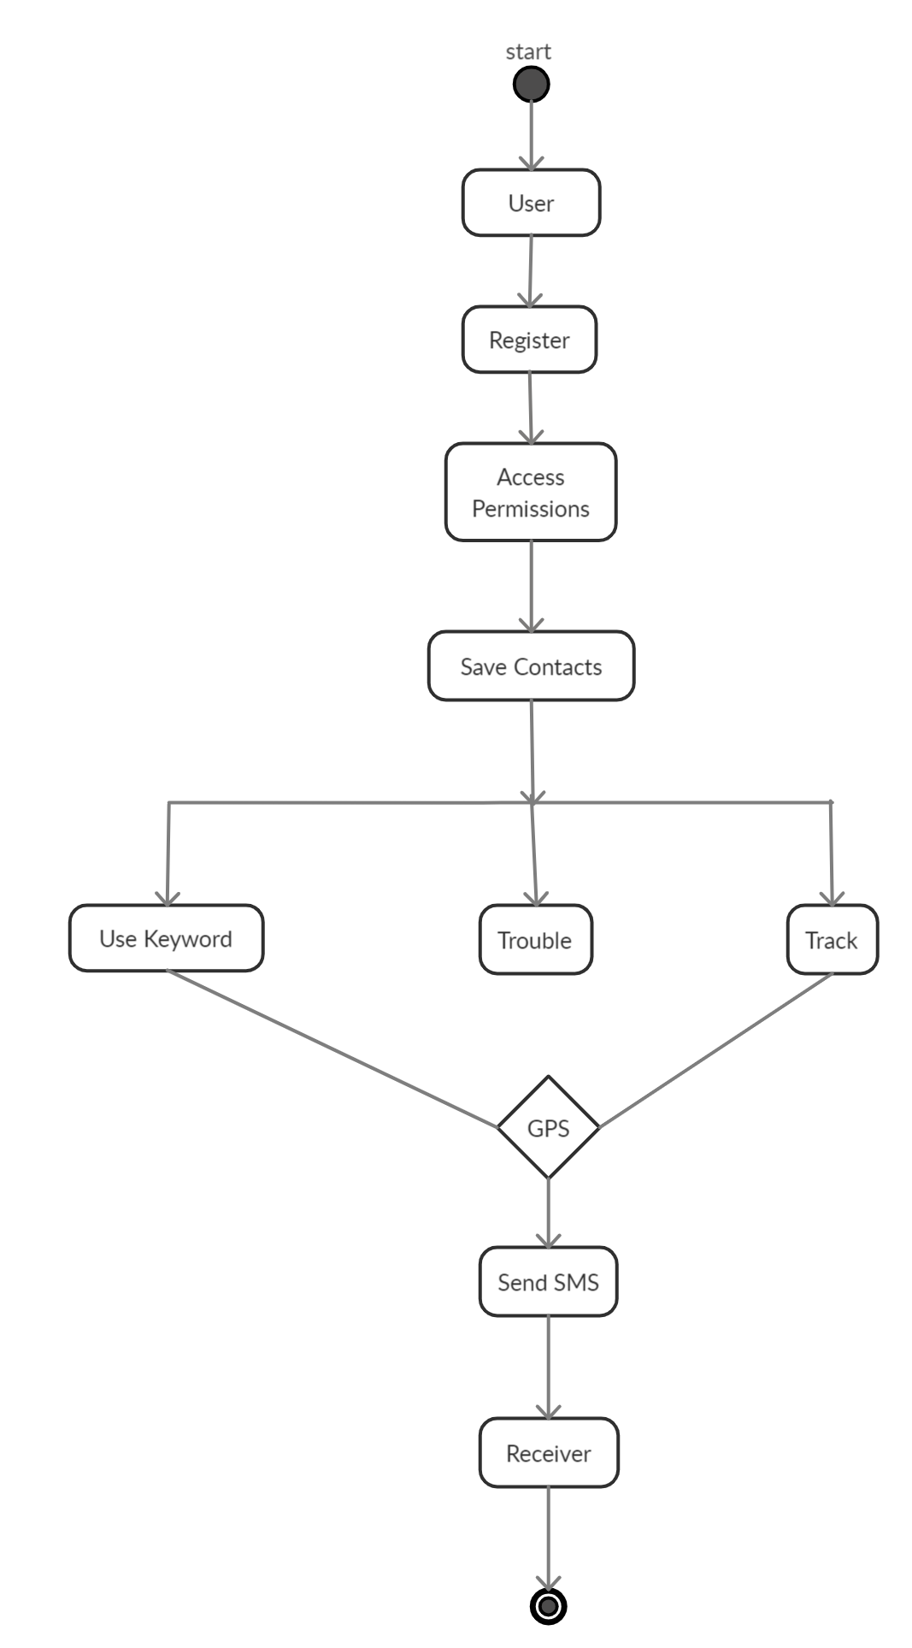
Fig 5: State chart Diagram

5.3 ER Diagrams
The relation upon the system is structure through a conceptual ER-Diagram, which not only specifies the existential entities but also the standard relations through which the system exists. ER diagram is a graphical representation of a system entities their attributes and the relationship between them. The set of primary components that are identified by the ERD are:

- Data object
- Relationships
- Attributes

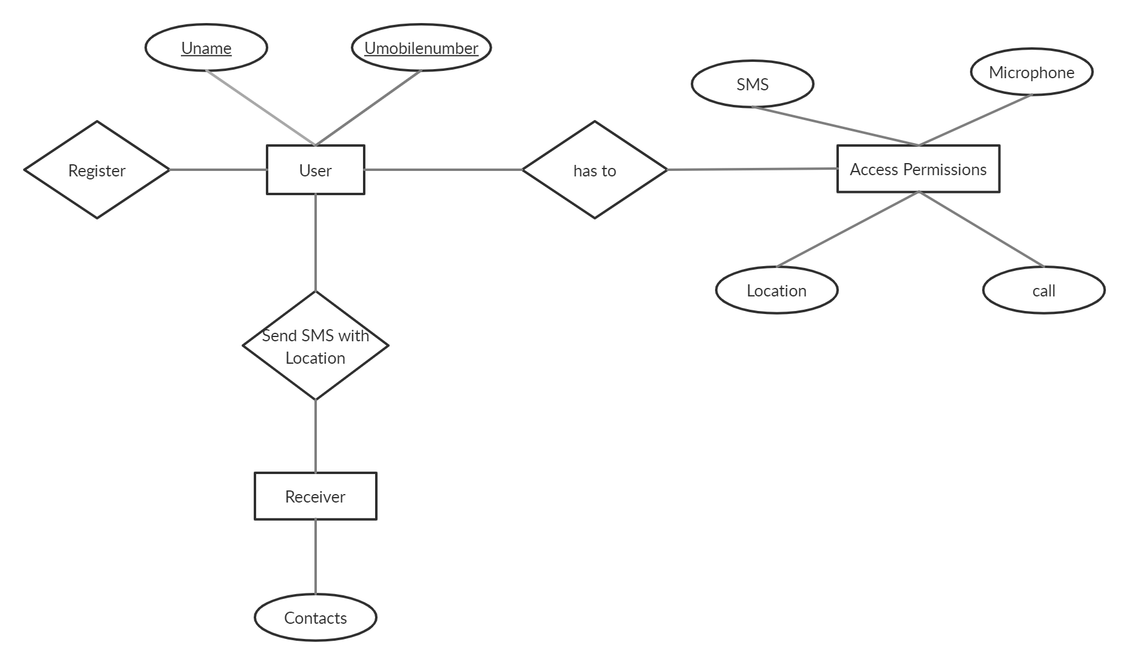
Fig 6: Entity Relationship Diagram

5.4 Data Flow Diagram:
A data-flow diagram is a way of representing a flow of a data of a process or a system The DFD also provides information about the outputs and inputs of each entity and the process itself. A data-flow diagram has no control flow, there are no decision rules and no loops.

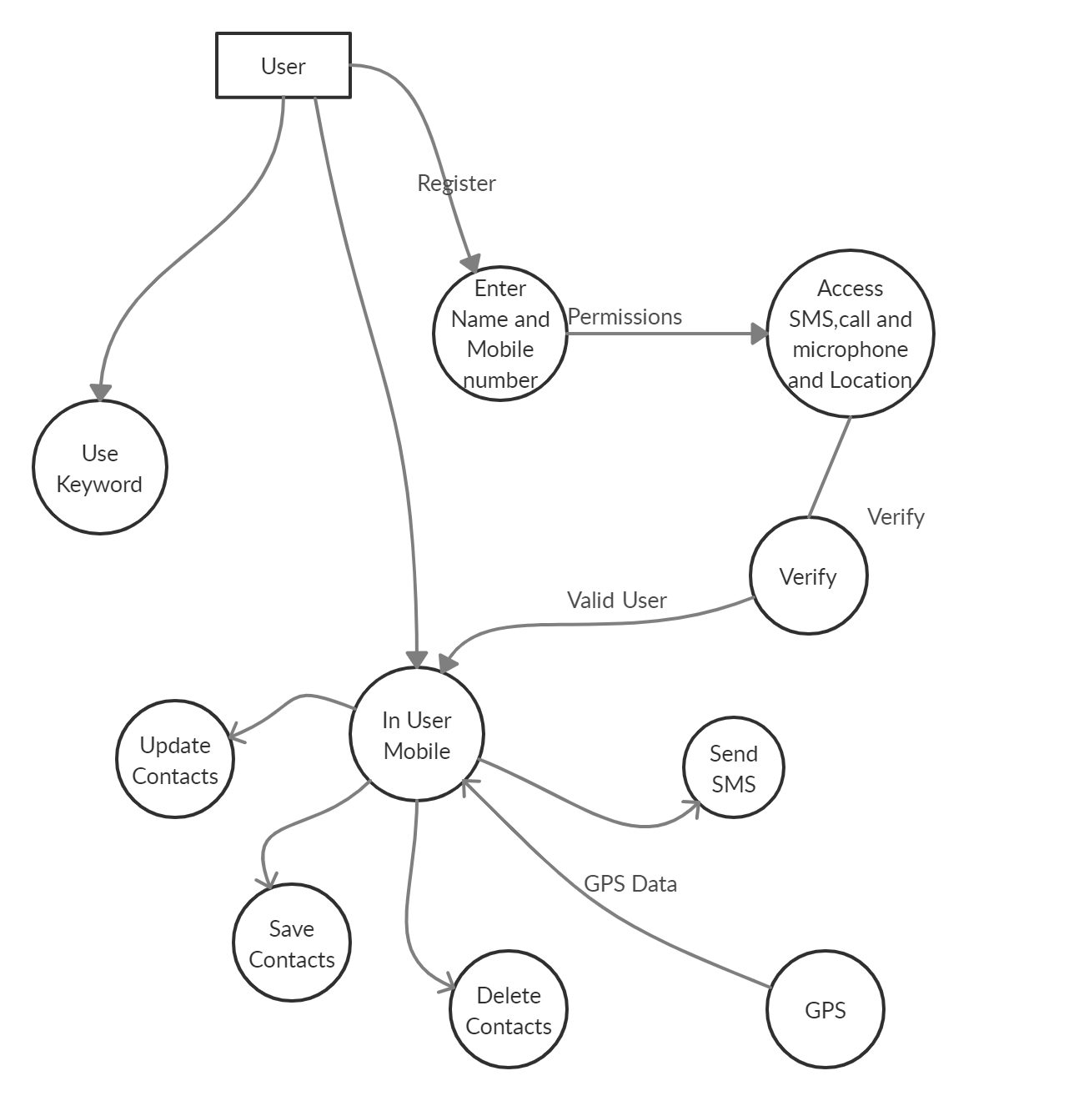
Fig 7: Data flow Diagram
6. TECHNOLOGY DESCRIPTION

6.1 JAVA
Java is an object-oriented language, and is very similar to C++. Java is simplified to eliminate language features that cause common programming errors. Java source code files are compiled into a format called byte code, which can then be executed by a Java interpreter. Features being
- Platform Independent
The programs written on one platform can run on any platform provided the platform must have the JVM.
- Portable
The feature Write-once-run-anywhere makes the java language portable provided that the system must have interpreter for the JVM.
- Simple
Programs are easy to write and debug because java does not use the pointers explicitly. It also has the automatic memory allocation and deallaocation system.
- Multithreaded
Multithreading means a single program having different threads executing independently at the same time.
- Robust
Java has the strong memory allocation and automatic garbage collection mechanism. It provides the powerful exception handling and type checking mechanism as compare to other programming languages.
- Object Oriented
To be an Object-Oriented language, any language must follow at least the four characteristics.
- Inheritance
- Encapsulation
- Polymorphism
- Dynamic binding
- Distributed
The widely used protocols like HTTP and FTP are developed in java. Internet programmers can call functions on these protocols and can get access to the files from any remote machine on the internet rather than writing codes on their local system.
- Secure
All the programs in java are run under an area known as the sand box. Security manager determines the accessibility options of a class like reading and writing a file to the local disk.
- High Performance
In the beginning interpretation of byte code resulted in slow performance but the advance version of JVM uses the adaptive and just in time compilation technique that improves the performance.
- Integrated
Java is an interpreted language as well. Programs run directly from the source code.

6.2 ANDROID
Android is a software stack for mobile devices that includes an operating system, middleware and key applications. The android SDK provides the tools and APIs necessary to begin developing applications on the Android platform using the Java programming language.
Features
Application framework enabling reuse and replacement of components
Dalvik virtual machine optimized for mobile devices
Integrated browser based on the open sourceWebKit engine
Optimized graphics powered by a custom 2D graphics library; 3D graphics based on the OpenGL ES 1.0 specification (hardware acceleration optional)
SQLite for structured data storage
Media support for common audio, video, and still image formats (MPEG4, H.264, MP3, AAC, AMR, JPG, PNG, GIF)
GSM Telephony (hardware dependent)
Bluetooth, EDGE, 3G, and Wi-Fi (hardware dependent)
Camera, GPS, compass, and accelerometer (hardware dependent)
Rich development environment including a device emulator, tools for debugging, memory and performance profiling, and a plug-in for the Eclipse IDE

Android application
Developers have full access to the same framework APIs used by the core applications. The application architecture is designed to simplify the reuse of components; any application can publish its capabilities and any other application may then make use of those capabilities (subject to security constraints enforced by the framework). This same mechanism allows components to be replaced by the user.
Libraries
Android includes a set of C/C++ libraries used by various components of the Android system. These capabilities are exposed to developers through the Android application framework. Some of the core libraries are listed below:
System C library: a BSD-derived implementation of the standard C system library (libc), tuned for embedded Linux-based devices
Media Libraries: based on Packet Video’s Open CORE; the libraries support playback and recording of many popular audio and video formats, as well as static image files, including MPEG4, H.264, MP3, AAC, AMR, JPG, and PNG
Surface Manager: manages access to the display subsystem and seamlessly composites 2D and 3D graphic layers from multiple applications
LibWebCore: a modern web browser engine which powers both the Android browser and an embeddable web view
SGL: the underlying 2D graphics engine
3D libraries: an implementation based on OpenGL ES 1.0 APIs; the libraries use either hardware 3D acceleration (where available) or the included, highly optimized 3D software rasterizer
Free Type: bitmap and vector font rendering
SQLite: a powerful and lightweight relational database engine available to all applications.
Android Runtime
Android includes a set of core libraries that provides most of the functionality available in the core libraries of the Java programming language.
Every Android application runs in its own process, with its own instance of the Dalvik virtual machine. Dalvik has been written so that a device can run multiple VMs efficiently. The Dalvik VM executes files in the Dalvik Executable format which is optimized for minimal memory footprint. The VM is register-based, and runs classes compiled by a Java language compiler that have been transformed into the. dex format by the included "dx" tool.
The Dalvik VM relies on the Linux kernel for underlying functionality such as threading and low-level memory management.
An Android code editor that helps you write valid XML for your Android manifest and resource files. It will even export your project into a signed APK, which can be distributed to users.
Developing in Android Studio:
Each project in Android Studio contains one or more modules with source code files and resource files. Types of modules include:
- Android app modules
- Library modules
- Google App Engine modules
By default, Android Studio displays your project files in the Android project view, This view is organized by modules to provide quick access to your project's key source files.
All the build files are visible at the top level under Gradle Scripts and each app module contains the following folders:
- manifests: Contains the AndroidManifest.xml file.
- java: Contains the Java source code files, including JUnit test code.
- res: Contains all non-code resources, such as XML layouts, UI strings, and bitmap images.
The Android project structure on disk differs from this flattened representation. To see the actual file structure of the project, select Project from the Project dropdown (in figure 1, it's showing as Android).
You can also customize the view of the project files to focus on specific aspects of your app development. For example, selecting the Problems view of your project displays links to the source files containing any recognized coding and syntax errors, such as a missing XML element closing tag in a layout file.
Creating the Project:
The ADT plug-in provides a New Project Wizard that you can use to quickly create a new Android project (or a project from existing code). To create a new project:
- Select File > New > Project.
- Select Android > Android Project, and click Next.
- Select the contents for the project:
- Enter a Project Name. This will be the name of the folder where your project is created.
- Under Contents, select Create new project in workspace. Select your project workspace location.
- Under Target, select an Android target to be used as the project's Build Target. The Build Target specifies which Android platform you'd like your application built against.
- Unless you know that you'll be using new APIs introduced in the latest SDK, you should select a target with the lowest platform version possible, such as Android 1.1.
- Under Properties, fill in all necessary fields:
Enter an Application name. This is the human-readable title for your application — the name that will appear on the Android device.
- Enter a Package name. This is the package namespace (following the same rules as for packages in the Java programming language) where all your source code will reside.
- Select Create Activity (optional, of course, but common) and enter a name for your main Activity class.
- Enter a Min SDK Version. This is an integer that indicates the minimum API Level required to properly run your application. Entering this here automatically sets the min Sdk Version attribute in the < HYPERLINK "http://developer.android.com/guide/topics/manifest/uses-sdk-element.html"uses-sdk HYPERLINK "http://developer.android.com/guide/topics/manifest/uses-sdk-element.html">of your Android Manifest file. If you're unsure of the appropriate API Level to use, copy the API Level listed for the Build Target you selected in the Target tab.
- Click Finish.
Once you complete the New Project Wizard, ADT creates the following folders and files in your new project:
src/
Includes your stub Activity Java file. All other Java files for your application go here.
<Android Version>/ (e.g., Android 1.1/)
Includes the android.jar file that your application will build against. This is determined by the build target that you have chosen in the New Project Wizard.
gen/
This contains the Java files generated by ADT, such as your R.java file and interfaces created from AIDL files.
assets/
This is empty. You can use it to store raw asset files. See Resources.
res/
A folder for your application resources, such as drawable files, layout files, string values, etc. See Resources and Assets.
AndroidManifest.xml
The Android Manifest for your project. See The AndroidManifest.xml File.
6.3 SQLite
SQLite is an ACID-compliant embedded relational contained in a relatively small C programming library. The source code for SQLite is in the public domain.
Unlike client-server database management systems, the SQLite engine is not a standalone process with which the application program communicates. Instead, the SQLite library is linked in and thus becomes an integral part of the application program. The library can also be called dynamically. The application program uses SQLite's functionality through simple function calls, which reduces latency in database access as function calls within a single process are more efficient than inter-process communication.
Introduction:
There are two basic rules for resource-constrained systems:
Don't do work that you don't need to do.
Don't allocate memory if you can avoid it.
All the tips below follow from these two basic tenets.
Some would argue that much of the advice on this page amounts to "premature optimization." While it's true that micro-optimizations sometimes make it harder to develop efficient data structures and algorithms, on embedded devices like handsets you often simply have no choice. For instance, if you bring your assumptions about VM performance on desktop machines to Android, you're quite likely to write code that exhausts system memory. This will bring your application to a crawl — let alone what it will do to other programs running on the system!
That's why these guidelines are important. Android's success depends on the user experience that your applications provide, and that user experience depends in part on whether your code is responsive and snappy, or slow and aggravating. Since all our applications will run on the same devices, we're all in this together, in a way. Think of this document as like the rules of the road you had to learn when you got your driver's license: things run smoothly when everybody follows them, but when you don't, you get your car smashed up.
Features:
SQLite implements most of the SQL-92 standard for SQL but it lacks some features. A standalone program called sqlite3 is provided which can be used to create a database, define tables within it, insert and change rows, run queries and manage an SQLite database file. SQLite is a popular choice for local/client SQL storage within a web browser and within a rich internet HYPERLINK "http://en.wikipedia.org/wiki/List_of_rich_internet_application_frameworks"application framework. This may be because SQLite's dynamically typed storage matches the web browser's core languages of JavaScript and XML. SQLite uses an unusual type system for an SQL-compatible DBMS. Instead of assigning a type to a column as in most SQL database systems, types are assigned to individual values; in language terms it is dynamically type.

- SCREENSHOTS
Some of the screenshots are: Once the User opens the app it shows the instructions and ask to allow speech to always run in the background.

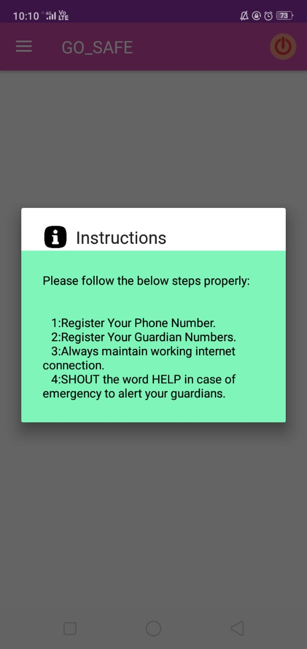
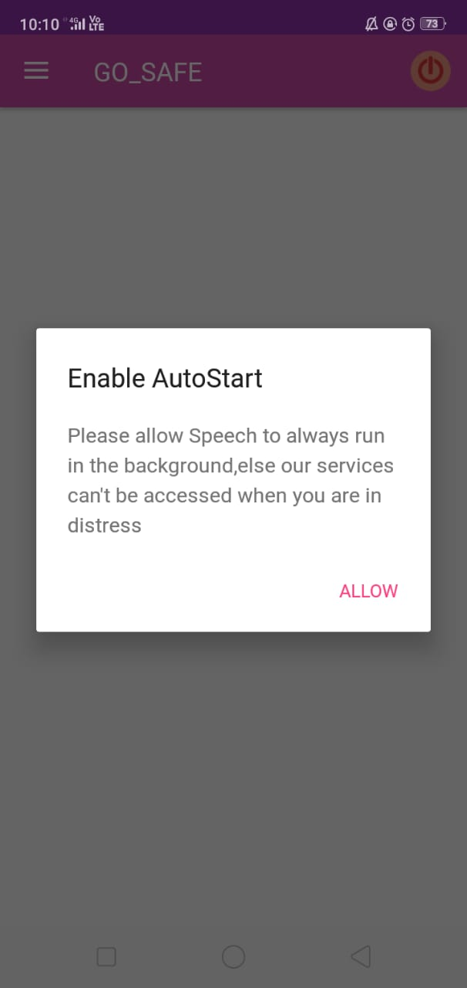

Once the user allows the permission, It will show the app with toggles Instructions, Register Myself where the user need to give her number, Register My Contacts where the user need to give contacts, Display Contacts where whatever the numbers given by user displays and Nearby Places.

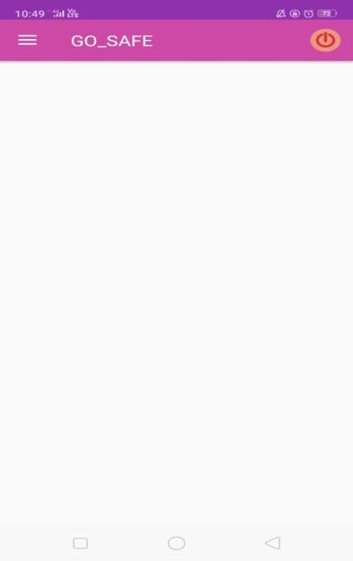

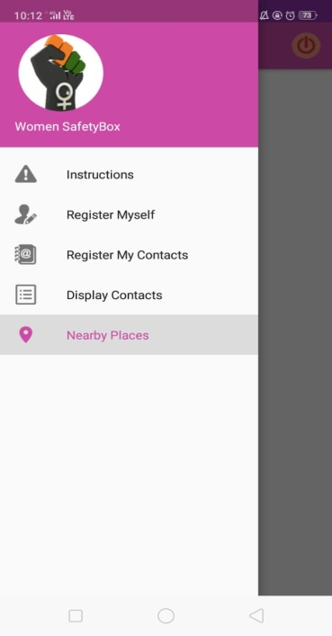

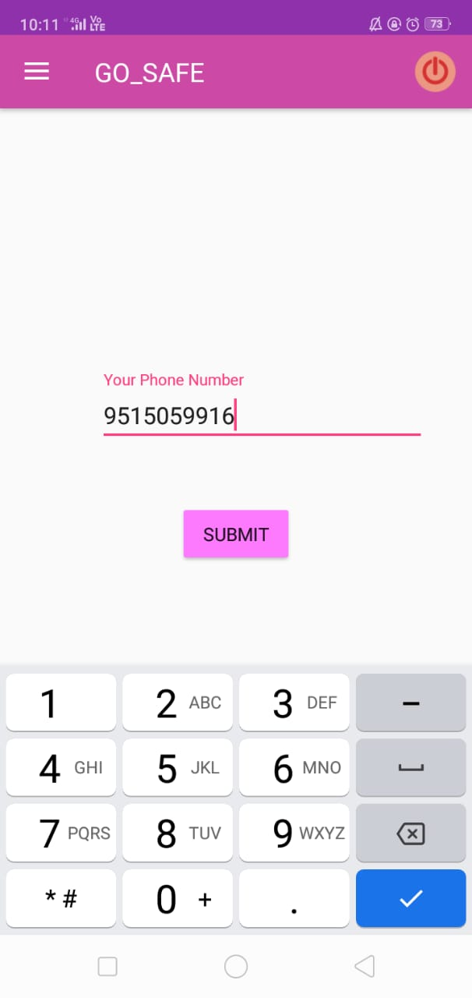

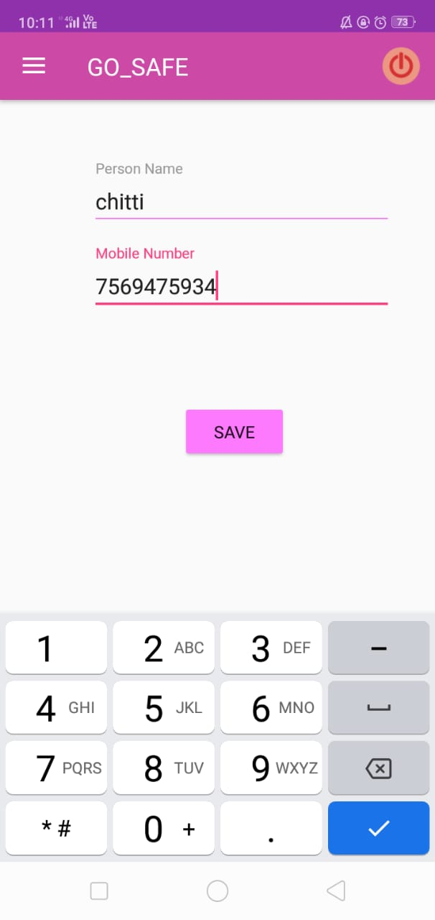

Then, the user should on the power button. When the user says the keyword help the message will be sent to saved contacts and call along with message will be sent to firstly stored contact.
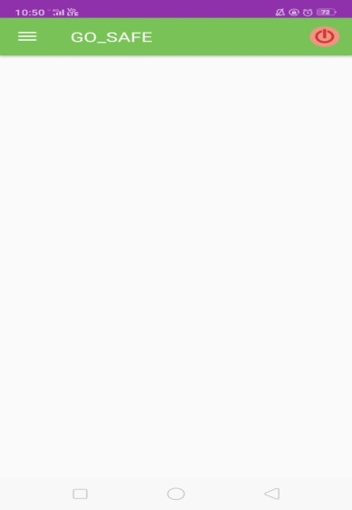
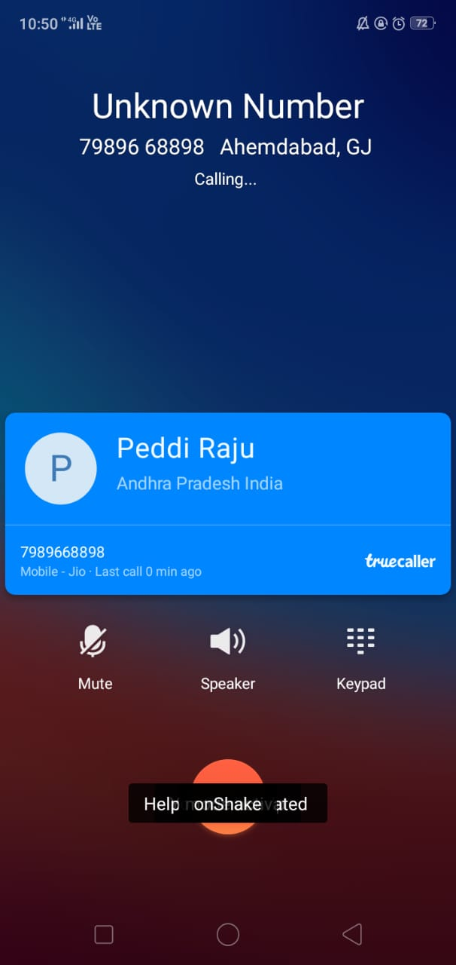
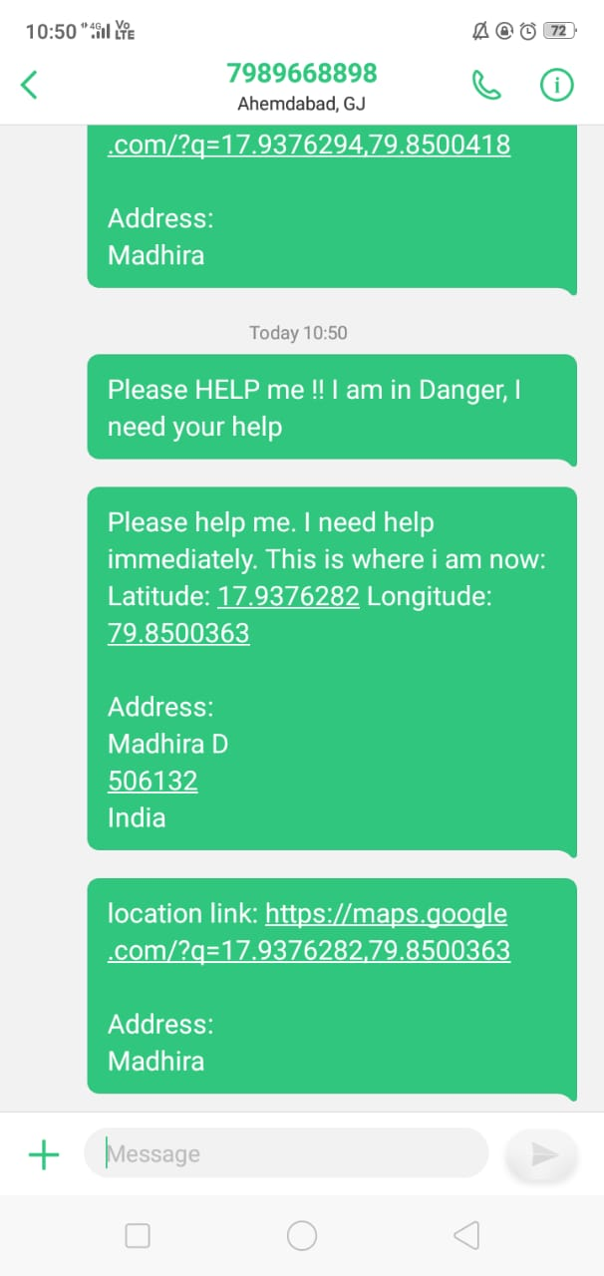

8. TESTING
8.1 Introduction
Software testing is the process of executing a program or system with the internet of finding errors or it involves any activity aimed at evaluating an attribute or capability of a program or a system and determining that it meet its required results .Software is not unlike other physical processes where inputs are received and output are produced. Where software differs is in the manner in which it is fails. Most physical systems fails in a fixed (and reasonable small) set of ways. By contrast, software can fail in many bizarre ways. Detecting all of the different failure modes for software is generally infeasible.
Module Testing
Here testing is done at each module level. Each case has been thoroughly tested to discover pitfalls.
System Testing
System Testing is a type of software testing that is performed on a complete integrated system to evaluate the compliance of the system with the corresponding requirements. In system testing, integration testing passed components are taken as input. The goal of integration testing is to detect any irregularity between the units that are integrated together. System testing detects defects within both the integrated units and the whole system. The result of system testing is the observed behavior of a component or a system when it is tested. System Testing is carried out on the whole system in the context of either system requirement specifications or functional requirement specifications or in the context of both. System testing tests the design and behavior of the system and also the expectations of the customer. It is performed to test the system beyond the bounds mentioned in the software requirement specification (SRS). System Testing is basically performed by a testing team that is independent of the development team that helps to test the quality of the system impartial. It has both functional and non-functional testing.

8.2 Software Testing
Software testing is an investigation conducted to provide stakeholders with information about the quality of the software product or service under test.[1] Software testing can also provide an objective, independent view of the software to allow the business to appreciate and understand the risks of software implementation. Test techniques include the process of executing a program or application with the intent of finding software bugs (errors or other defects), and verifying that the software product is fit for use. Software testing involves the execution of a software component or system component to evaluate one or more properties of interest. In general, these properties indicate the extent to which the component or system under test meets the requirements that guided its design and development, responds correctly to all kinds of inputs, performs its functions within an acceptable time, it is sufficiently usable.
8.3 Unit Testing
The software units in the system is are modules and routines that are assembled and integrated to perform a specific function. As a part of unit testing, we executed the program for individual modules independently. This enables, to detect errors in coding and logic that are contained within each of the three modules. This testing includes entering data that is filling forms and ascertaining if the value matches to the type and entered into the database. The various controls are tested to ensure that each performs its action as required.
8.4 Test Cases
Test case 1:
To validate whether all the required mandatory fields are working as required.
Test case 2:
To validate that the mandatory fields are displayed in the screen in a distinctive way than the non-mandatory fields.

Test case 3:
To validate whether the application works as per as requirement whenever the application starts/stops.
Test case 4:
To validate whether the application goes into minimized mode whenever there is an incoming phone call. In order to validate the same we need to use a second phone, to call the device.
Test case 5:
To validate whether the phone is able to store, process and receive SMS whenever the app is running. In order to validate the same we need to use a second phone to send SMS to the device which is being tested and where the application under test is currently running.
Test case 6:
To validate that the device is able to perform required multitasking requirements whenever it is necessary to do so.
Test case 7:
To validate that the application allows necessary social network options such as sharing, posting and navigation etc.
Test case 8:
To validate that the page scrolling scenarios are being enabled in the application as necessary.
Test case 9:
To validate that the navigation between relevant modules in the application are as per the requirement.
Test case 10:
To determine whether the application performs as per the requirement under different load conditions.
Test case 11:
To determine whether the current network coverage is able to support the application at peak, average and minimum user levels.
Test case 12:
To determine whether the existing client-server configuration setup provides the required optimum performance level.
Test case 13:
To identify the various application and infrastructure bottlenecks which prevent the application to perform at the required acceptability levels.
Test case 14:
To validate whether the response time of the application is as per as the requirements.
Test case 15:
To prevent the application from all security attacks in order to provide better security for the users and make the app user-friendly.

9. SAMPLE CODE
MainActivity.java
package com.womensafety.sirichandana;
import android.app.ActivityManager;
import android.content.Intent;
import android.content.pm.PackageManager;
import android.database.sqlite.SQLiteDatabase;
import android.graphics.Color;
import android.graphics.drawable.ColorDrawable;
import android.os.Bundle;
import android.support.design.widget.NavigationView;
import android.support.v4.app.Fragment;
import android.support.v4.app.FragmentTransaction;
import android.support.v4.view.GravityCompat;
import android.support.v4.widget.DrawerLayout;
import android.support.v7.app.ActionBarDrawerToggle;
import android.support.v7.app.AlertDialog;
import android.support.v7.app.AppCompatActivity;
import android.support.v7.widget.ShareActionProvider;
import android.support.v7.widget.Toolbar;
import android.util.Log;
import android.view.LayoutInflater;
import android.view.Menu;
import android.view.MenuItem;
import android.view.View;
import android.widget.Button;
import android.widget.TextView;
import com.afollestad.materialdialogs.MaterialDialog;
import com.afollestad.materialdialogs.Theme;
import com.codemybrainsout.ratingdialog.RatingDialog;
public class MainActivity extends AppCompatActivity
implements NavigationView.OnNavigationItemSelectedListener {
public static Boolean isActive = false;
private Button btStartService;
private TextView tvText;
private ShareActionProvider ShareActionProvider;
@Override
protected void onCreate(Bundle savedInstanceState) {
super.onCreate(savedInstanceState);
setContentView(R.layout.activity_main);
Toolbar toolbar = (Toolbar) findViewById(R.id.toolbar);
setSupportActionBar(toolbar);
btStartService = (Button) findViewById(R.id.btStartService);
tvText = (TextView) findViewById(R.id.tvText);
enableAutoStart();
if (checkServiceRunning()) {
btStartService.setText(getString(R.string.stop_service));
tvText.setVisibility(View.VISIBLE);
}
btStartService.setOnClickListener(v -> {
if (btStartService.getText().toString().equalsIgnoreCase(getString(R.string.start_service))) {
startService(new Intent(MainActivity.this, MyService.class));
btStartService.setText(getString(R.string.stop_service));
tvText.setVisibility(View.VISIBLE);
} else {
stopService(new Intent(MainActivity.this, MyService.class));
btStartService.setText(getString(R.string.start_service));
tvText.setVisibility(View.GONE);
}
});
DrawerLayout drawer = (DrawerLayout) findViewById(R.id.drawer_layout);
ActionBarDrawerToggle toggle = new ActionBarDrawerToggle(
this, drawer, toolbar, R.string.navigation_drawer_open, R.string.navigation_drawer_close);
drawer.addDrawerListener(toggle);
toggle.syncState();
NavigationView navigationView = (NavigationView) findViewById(R.id.nav_view);
navigationView.setNavigationItemSelectedListener(this);
displaySelectedScreen(R.id.nav_inst);
/*
//wi;; delete
SQLiteDatabase db = openOrCreateDatabase("NumDB", Context.MODE_PRIVATE, null);
Cursor c = db.rawQuery("SELECT * FROM details", null);
while (c.moveToFirst())
{
Log.d("Number", c.getString(1));
}
}
@Override
public boolean onOptionsItemSelected(MenuItem item) {
switch (item.getItemId()) {
case R.id.action_power:
android.support.v7.app.ActionBar bar = getSupportActionBar();
//item.setTitle("changed");
Log.d("Title:", item.getTitle().toString());
if (item.getTitle().toString().contains("START")) {
Log.d("Title2:", "If er vitore");
SQLiteDatabase db2 = this.openOrCreateDatabase("NumberDB", MODE_PRIVATE, null);
Log.d("Number is:", Register.getNumber(db2));
bar.setBackgroundDrawable(new ColorDrawable(Color.parseColor("#78C257")));
startService(new Intent(MainActivity.this, MyService.class));
item.setTitle("STOP SERVICE");
return true;
}
else
{
bar.setBackgroundDrawable(new ColorDrawable(Color.parseColor("#E81123")));
startService(new Intent(MainActivity.this, MyService.class));
item.setTitle("START SERVICE");
return true;
}
/*
bar.setBackgroundDrawable(new ColorDrawable(Color.parseColor("#439EB8")));
stopService(new Intent(MainActivity.this, MyService.class));
return true;
*/
default:
// If we got here, the user's action was not recognized.
// Invoke the superclass to handle it.
return super.onOptionsItemSelected(item);
}
}
protected void onDestroy() {
super.onDestroy();
}
private boolean checkServiceRunning() {
ActivityManager manager = (ActivityManager) getSystemService(ACTIVITY_SERVICE);
if (manager != null) {
for (ActivityManager.RunningServiceInfo service : manager.getRunningServices(
Integer.MAX_VALUE)) {
if (getString(R.string.my_service_name).equals(service.service.getClassName())) {
return true;
}
}
}
return false;
}
private void enableAutoStart() {
for (Intent intent : Constants.AUTO_START_INTENTS) {
if (getPackageManager().resolveActivity(intent, PackageManager.MATCH_DEFAULT_ONLY) != null) {
new MaterialDialog.Builder(this).title(R.string.enable_autostart)
.content(R.string.ask_permission)
.theme(Theme.LIGHT)
.positiveText(getString(R.string.allow))
.onPositive((dialog, which) -> {
try {
for (Intent intent1 : Constants.AUTO_START_INTENTS)
if (getPackageManager().resolveActivity(intent1, PackageManager.MATCH_DEFAULT_ONLY)
!= null) {
startActivity(intent1);
break;
}
} catch (Exception e) {
e.printStackTrace();
}
})
.show();
break;
}
}
}
@Override
public void onBackPressed() {
DrawerLayout drawer = (DrawerLayout) findViewById(R.id.drawer_layout);
if (drawer.isDrawerOpen(GravityCompat.START)) {
drawer.closeDrawer(GravityCompat.START);
} else {
super.onBackPressed();
}
}
@Override
public boolean onCreateOptionsMenu(Menu menu) {
// Inflate menu resource file.
getMenuInflater().inflate(R.menu.newbutton, menu);
// Locate MenuItem with ShareActionProvider
// MenuItem item = menu.findItem(R.id.menu_share);
// Fetch and store ShareActionProvider
//mShareActionProvider = (ShareActionProvider) MenuItemCompat.getActionProvider(item);
//setIntent("Testing Share Feature");
// Return true to display menu
return true;
}
// Call to update the share intent
private void setIntent(String s) {
Intent intent=new Intent(Intent.ACTION_SEND);
intent.setType("text/html");
intent.putExtra(Intent.EXTRA_TEXT,s);
mShareActionProvider.setShareIntent(intent);
}
/* @Override
public boolean onCreateOptionsMenu(Menu menu) {
// Inflate the menu; this adds items to the action bar if it is present.
getMenuInflater().inflate(R.menu.main, menu);
return true;
}
*/
/* @Override
public boolean onOptionsItemSelected(MenuItem item) {
// Handle action bar item clicks here. The action bar will
// automatically handle clicks on the Home/Up button, so long
// as you specify a parent activity in AndroidManifest.xml.
int id = item.getItemId();
//noinspection SimplifiableIfStatement
if (id == R.id.action_settings) {
return true;
}
return super.onOptionsItemSelected(item);
}*/
@SuppressWarnings("StatementWithEmptyBody")
@Override
public boolean onNavigationItemSelected(MenuItem item) {
displaySelectedScreen(item.getItemId());
// Handle navigation view item clicks here.
/*int id = item.getItemId();
if (id == R.id.nav_camera) {
// Handle the camera action
} else if (id == R.id.nav_gallery) {
} else if (id == R.id.nav_slideshow) {
} else if (id == R.id.nav_manage) {
} *//*else if (id == R.id.nav_share) {
} else if (id == R.id.nav_send) {
}*/
/* DrawerLayout drawer = (DrawerLayout) findViewById(R.id.drawer_layout);
drawer.closeDrawer(GravityCompat.START);*/
return true;
}
private void displaySelectedScreen(int itemId) {
//creating fragment object
Fragment fragment = null;
//initializing the fragment object which is selected
switch (itemId) {
case R.id.nav_inst: {
LayoutInflater inflater = getLayoutInflater();
View alertLayout = inflater.inflate(R.layout.popup_layout, null);
AlertDialog alertDialog = new AlertDialog.Builder(
MainActivity.this).create();
// Setting Dialog Title
alertDialog.setTitle("Instructions");
// Setting Dialog Message
alertDialog.setView(alertLayout);
// Setting Icon to Dialog
alertDialog.setIcon(R.drawable.instruct_icon);
// Showing Alert Message
alertDialog.show();
}break;
case R.id.nav_verify:
fragment = new Verify();
break;
case R.id.nav_register:
fragment = new Register();
break;
case R.id.nav_display:
fragment = new Display();
break;
case R.id.nav_nearby:
Intent i = new Intent(MainActivity.this,MapsActivity.class);
startActivity(i);
break;
}
//replacing the fragment
if (fragment != null) {
FragmentTransaction ft = getSupportFragmentManager().beginTransaction();
ft.replace(R.id.content_frame,fragment);
ft.commit();
}
DrawerLayout drawer = (DrawerLayout) findViewById(R.id.drawer_layout);
drawer.closeDrawer(GravityCompat.START);
}
}

MyService.java

package com.womensafety.sirichandana;
import android.Manifest.permission;
import android.app.AlarmManager;
import android.app.PendingIntent;
import android.app.Service;
import android.content.Context;
import android.content.Intent;
import android.database.Cursor;
import android.database.sqlite.SQLiteDatabase;
import android.media.AudioManager;
import android.net.Uri;
import android.os.Build.VERSION;
import android.os.Build.VERSION_CODES;
import android.os.Bundle;
import android.os.Handler;
import android.os.IBinder;
import android.os.Message;
import android.telephony.SmsManager;
import android.text.TextUtils;
import android.util.Log;
import android.widget.Toast;
import com.sac.speech.GoogleVoiceTypingDisabledException;
import com.sac.speech.Speech;
import com.sac.speech.SpeechDelegate;
import com.sac.speech.SpeechRecognitionNotAvailable;
import com.tbruyelle.rxpermissions.RxPermissions;
import java.util.List;
import java.util.Objects;
import java.util.Random;
public class MyService extends Service implements SpeechDelegate, Speech.stopDueToDelay {
String str_address;
String finalloc;
String linkloc = "https://maps.google.com/?q=";
String[] add= new String[20];
public static SpeechDelegate delegate;
@Override
public int onStartCommand(Intent intent, int flags, int startId) {
try {
if (VERSION.SDK_INT >= VERSION_CODES.KITKAT) {
((AudioManager) Objects.requireNonNull(
getSystemService(Context.AUDIO_SERVICE))).setStreamMute(AudioManager.STREAM_SYSTEM, true);
}
} catch (Exception e) {
e.printStackTrace();
}
Speech.init(this);
delegate = this;
Speech.getInstance().setListener(this);
if (Speech.getInstance().isListening()) {
Speech.getInstance().stopListening();
muteBeepSoundOfRecorder();
} else {
System.setProperty("rx.unsafe-disable", "True");
RxPermissions.getInstance(this).request(permission.RECORD_AUDIO).subscribe(granted -> {
if (granted) { // Always true pre-M
try {
Speech.getInstance().stopTextToSpeech();
Speech.getInstance().startListening(null, this);
} catch (SpeechRecognitionNotAvailable exc) {
//showSpeechNotSupportedDialog();
} catch (GoogleVoiceTypingDisabledException exc) {
//showEnableGoogleVoiceTyping();
}
} else {
Toast.makeText(this, R.string.permission_required, Toast.LENGTH_LONG).show();
}
});
muteBeepSoundOfRecorder();
}
return Service.START_STICKY;
}
@Override
public IBinder onBind(Intent intent) {
return null;
}
@Override
public void onStartOfSpeech() {
}
@Override
public void onSpeechRmsChanged(float value) {
}
@Override
public void onSpeechPartialResults(List<String> results) {
for (String partial : results) {
Log.d("Result", partial + "");
}
}
@Override
public void onSpeechResult(String result) {
Log.d("Result", result + "");
if (!TextUtils.isEmpty(result)) {
Toast.makeText(this, "You Said : " + result, Toast.LENGTH_SHORT).show();
if (result.contains("help") || result.contains("bachao")) {
//Toast.makeText(this, "Help mode activated ", Toast.LENGTH_SHORT).show();
Toast.makeText(this, "Help mode activated ", Toast.LENGTH_SHORT).show();
GPSTracker gps;
gps = new GPSTracker(MyService.this);
if(gps.canGetLocation()){
double latitude = gps.getLatitude();
double longitude = gps.getLongitude();
RGeocoder RGeocoder = new RGeocoder();
RGeocoder.getAddressFromLocation(latitude, longitude,getApplicationContext(), new MyService.GeocoderHandler());
Toast.makeText(getApplicationContext(), "onShake", Toast.LENGTH_SHORT).show();
}
else{
gps.showSettingsAlert();
}
SQLiteDatabase db2 = this.openOrCreateDatabase("NumberDB", MODE_PRIVATE, null);
Log.d("Number is:", Register.getNumber(db2));
SmsManager smsManager = SmsManager.getDefault();
smsManager.sendTextMessage(Register.getNumber(db2), null, "Please HELP me !! I am in Danger, I need your help", null, null);
Intent intent = new Intent(Intent.ACTION_CALL);
intent.setData(Uri.parse("tel:" + Register.getNumber(db2)));
intent.addFlags(Intent.FLAG_ACTIVITY_NEW_TASK);
intent.addFlags(Intent.FLAG_FROM_BACKGROUND);
startActivity(intent);
Toast.makeText(this, "Help mode activated ", Toast.LENGTH_SHORT).show();
}
}
}
public class GeocoderHandler extends Handler {
@Override
public void handleMessage(Message message) {
Toast.makeText(getApplicationContext(), "geocoderhandler started", Toast.LENGTH_SHORT).show();
switch (message.what) {
case 1:
Bundle bundle = message.getData();
str_address = bundle.getString("address");
// TelephonyManager tmgr=(TelephonyManager)BgService.this.getSystemService(Context.TELEPHONY_SERVICE);
// String ph_number=tmgr.getLine1Number();
SQLiteDatabase db2;
db2 = openOrCreateDatabase("NumberDB", Context.MODE_PRIVATE, null);
Cursor c=db2.rawQuery("SELECT * FROM details", null);
while(c.moveToNext())
{
add = str_address.split(" ");
linkloc = "https://maps.google.com/?q="+add[1]+","+add[3];
finalloc=linkloc+str_address;
String target_ph_number=c.getString(1);
SmsManager smsManager=SmsManager.getDefault();
smsManager.sendTextMessage(target_ph_number, null, "Please help me. I need help immediately. This is where i am now: "+str_address, null, null);
smsManager.sendTextMessage(target_ph_number, null, "location link: "+linkloc, null, null);
Toast.makeText(getApplicationContext(), "Target:"+target_ph_number, Toast.LENGTH_SHORT).show();
}
db2.close();
break;
default:
str_address = null;
}
Toast.makeText(getApplicationContext(), str_address, Toast.LENGTH_SHORT).show();
}
}
@Override
public void onSpecifiedCommandPronounced(String event) {
try {
if (VERSION.SDK_INT >= VERSION_CODES.KITKAT) {
((AudioManager) Objects.requireNonNull(
getSystemService(Context.AUDIO_SERVICE))).setStreamMute(AudioManager.STREAM_SYSTEM, true);
}
} catch (Exception e) {
e.printStackTrace();
}
if (Speech.getInstance().isListening()) {
muteBeepSoundOfRecorder();
Speech.getInstance().stopListening();
} else {
RxPermissions.getInstance(this).request(permission.RECORD_AUDIO).subscribe(granted -> {
if (granted) { // Always true pre-M
try {
Speech.getInstance().stopTextToSpeech();
Speech.getInstance().startListening(null, this);
} catch (SpeechRecognitionNotAvailable exc) {
//showSpeechNotSupportedDialog();
} catch (GoogleVoiceTypingDisabledException exc) {
//showEnableGoogleVoiceTyping();
}
} else {
Toast.makeText(this, R.string.permission_required, Toast.LENGTH_LONG).show();
}
});
muteBeepSoundOfRecorder();
}
}
private void muteBeepSoundOfRecorder() {
AudioManager amanager = (AudioManager) getSystemService(Context.AUDIO_SERVICE);
if (amanager != null) {
amanager.setStreamMute(AudioManager.STREAM_NOTIFICATION, true);
amanager.setStreamMute(AudioManager.STREAM_ALARM, true);
amanager.setStreamMute(AudioManager.STREAM_MUSIC, true);
amanager.setStreamMute(AudioManager.STREAM_RING, true);
amanager.setStreamMute(AudioManager.STREAM_SYSTEM, true);
}
}
@Override
public void onTaskRemoved(Intent rootIntent) {
PendingIntent service =
PendingIntent.getService(getApplicationContext(), new Random().nextInt(),
new Intent(getApplicationContext(), MyService.class), PendingIntent.FLAG_ONE_SHOT);
AlarmManager alarmManager = (AlarmManager) getSystemService(Context.ALARM_SERVICE);
assert alarmManager != null;
alarmManager.set(AlarmManager.ELAPSED_REALTIME_WAKEUP, 1000, service);
super.onTaskRemoved(rootIntent);
}
}

10. CONCLUSION

Here, we described Go_Safe, an Android application for women safety. This application helps in tracking the live Location of the user through GPS along with the contacts receives an SMS from the root device. Our application has an additional feature of voice recognition then the whole screen enable as a button. This application sends message to contacts saved in database and it also sends the location in the form of Hyperlink. This system uses GPS to detect current position of user in the form of latitude and longitude coordinates and SQLite database to store contacts to which they has to send the SMS. When the user is in danger and asks for help then the application will activate in the background and sends SMS with location link by recognizing the voice. The merit of this application is when the user location changes, then also the receiver can track the exact Location.

11. FUTURE ENHANCEMENTS

This project has a very great quantity of scope in future. The computer technology keeps finding new methods and technologies on a day to day basis. This project is dynamic not static. This project is used whenever a person is in danger.
There is scope for future development of this project. The computer technology keeps finding new methods and technologies on a day to day basis. It is a dynamic and not static. The skills which are prominent today will become obsolete in a few days. To keep in place the technical developments, the system may be additionally improved. So, it is not concluded. Yet it’ll improve with further augmentations. Augmentations can be done in an effectual manner. We can even apprise the same with further changes and can be integrated with minimal alteration. Thus the project is flexible and can be improved at anytime with more progressive features.

12. BIBLIOGRAPHY

- https://www.semanticscholar.org/paper/%E2%80%98Street-Smart%E2%80%99%3A-Safe-Street-App-for-Women-Using-Chaudhari-Kamte/38aa5de4fa7f6c8081e3000fdff23c0b2cde611d
- 2.https://www.researchgate.net/publication/287201587_Abhaya_An_Android_App_For_The_Safety_Of_Women
- VaijayantiPawar, Prof.N.R.Wankhade, DipikaNikam, KanchanJadhav, NehaPathak, “SCIWARS Android App for Women Safety,” VaijayantiPawar et al Int. Journal of Engineering Research and Applications, www.ijera.com, ISSN: 2248-9622, Vol. 4, Issue 3(Version 1), March 2014, pp.823-826.
- Robi Grgurina, Brestovac and Tihana Galinac Grbac, “Development Environment for Android Application Development: An Experience Report,” MIPRO 2011, May 23-27, 2011, Opatija, Croatia.

- Android App developed by Canvas M Technologies, 26 June, 2013, “FIGHTBACK”, http://www.fightbackmobile.com/welcome.

- Android App developed by Think MPI Consulting Private Limited, 29 September,2014,”SECUREMEBETA”, https://play.google.com/store/apps/details?id=com.thinkmpi.app.secure me&hl=en.

